$$\boxed{\boxed{ DEFLECTION BY VIRTUAL WORK METHOD }}$$

- Principle of virtual work for Rigid Bodies.

Consider a truly rigid body which is in static equilibrium under a system of forces Q_{i}.
Suppose this rigid body is TRANSLATED a small amount (say${ δ}_{0}$) by some other cause (which is independent of Q_{i} force system).
Since $δ_{0}$ is small all Q_{i} forces are assumed to maintain the same position and direction relative to the rigid body and to each other, and hence to maintain EQUILIBRIUM during this rigid translation:

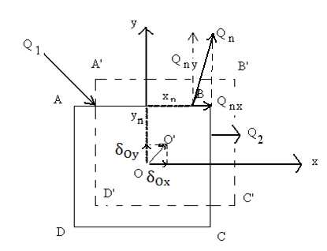

${\sum{Q}}_{nX}$ ${\underset{→}{+} \atop =}$ 0 (10)

${\sum{Q}}_{nY}$ ${↑+ \atop =}$ 0 (11)

${\sum{M}}_{0}$ = 0 ${ \atop =}$ $\sum{{(Q}_{nx}*y_{n})+(-Q_{ny}*x_{n})}$ (12)

Work done by the
Q_{i} forces = $W_{Q}$ = $\sum{{(Q}_{nx}δ_{Ox}+ Q_{ny}δ_{Oy})=(δ_{Ox})\sum{Q_{nx}+ (δ_{Oy} )\sum{Q_{ny}}}}$ (13)

Zero
${ W}_{Q}=0$ (14)

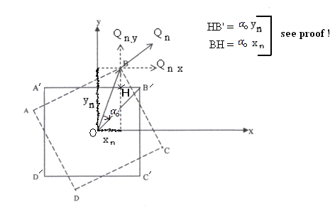
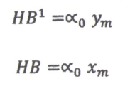
Similarly , if the rigid body is ROTATED a small amount $∝_{0}$ by some other cause (which is independent of $Q_{i}$ forces), then:
43
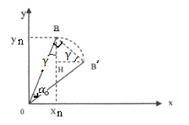

Since: $α_{0}$is a small angle $⇒$ $\hat{OBB'}≈{90}^{o}$
Hence $\hat{OBH}≡γ≅ \hat{HB'B}$
We have:
$OB=\sqrt{x_{n}^{2}+y_{n}^{2}}$ And $BB^{'}≈\left(OB\right)\left(α_{o}^{rad}\right)=\sqrt{x_{n}^{2}+y_{n}^{2}} (α_{o})$
$HB^{'}=BB^{'}*\cos{(γ)}=BB^{'}*\frac{y_{n}}{OB}=\sqrt{x_{n}^{2}+y_{n}^{2}} \left(α_{o}\right)*\frac{y_{n}}{\sqrt{x_{n}^{2}+y_{n}^{2}}}=∝_{o}y_{n}$
$BH=BB^{'}*\sin{(∝)}= BB^{'}*\frac{x_{n}}{OB}=\sqrt{x_{n}^{2}+y_{n}^{2}} \left(α_{o}\right)*\frac{x_{m}}{\sqrt{x_{n}^{2}+y_{n}^{2}}}=∝_{o}x_{n}$
Now,
$W_{Q}=\sum{(}Q_{nx}*HB^{'}-Q_{ny}*BH)=\sum{(}Q_{nx}*∝_{o}y_{m}-Q_{ny}*∝_{o}x_{n})$……(15)
$W_{Q}=\left(∝_{o}\right)\sum{{(Q}_{nx}}y_{n}-Q_{ny}x_{n})=0$
Zero (see Eq. 12)

\

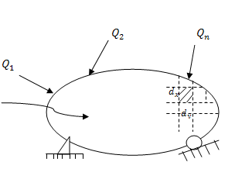
- Principal of Virtual Work for Deformable Bodies:
44

Step 1: This deformable body is in
Equilibrium under the applied
virtual forces $Q_{i}$ and support
reactions.

Step 2: Now , suppose the body is subjected to a small change
in shape, caused by another load P system (which is independent
from $Q_{i}$ system)
Step 3: Any INTERIOR particle, with dimensions $d_{x}$ and$d_{y}$, will be displaced in its boundary and will have its virtual work to be canceled
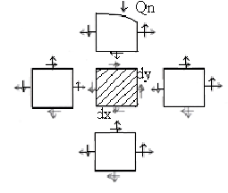
by its adjacent particle(s).

Step 4:

Virtual work done on the EXTERIOR (or boundary)

Particle is given by: $dw_{S}=dw_{R}+dw_{d}…………….(16)$

Where: $dw_{R}=due to RIGID body Translation \& Rotation = 0 (see Eq. 14 \& Eq. 15)$
$dw_{d}=due to deformable body$

Hence: $dw_{S}= dw_{d}⇒∫dw_{S}=∫ dw_{d}$ or $\boxed{w_{s}=w_{d}}$………(17)

(C) How to Evaluate $W_{S} \&{ W}_{d}$in Eq. (17) ?
45
In Eq. (17), one has: $W_{s} = W_{d}$

Where $W_{S} \&{ W}_{d}$ represents the External Virtual Work (VW),
and the Internal V.W., respectively

$W_{s} = Q*δ =$ (“Virtual” Force or Moment) *(“Real” Displacement, or Rotation) ……..(18)

The internal V.W. (=$W_{d})$ of deformation can be computed as:

$W_{d}={(W_{d})}_{Axial}+{(W_{d})}_{Bending}+{(W_{d})}_{Torsion}+{(W_{d})}_{Shear}$ ………..(19)

With:
$${(W_{d})}_{Axial}=\left(F_{Q}\right)*\left(∆L_{real}=\frac{F_{p}L}{AE}+α_{T}*∆T*L+∆L_{Fabrication Error}\right)…(19a)$$
${(W_{d})}_{Bending}=\sum_{All members}{\int_{s=0}^{L}{\int_{y=\frac{-h}{2}}^{\frac{h}{2}}{\left(\frac{M_{Q}y}{I}\right)(bdy)}*\left(\frac{M_{p}y}{IE}\right)}*\left(ds\right)=\sum{\int_{O}^{L}{M_{Q}*\frac{M_{p}ds}{EI}..(19b)}}}$
Length
Strain
“Real” Displacement
Stress
Area
“Virtual” Force

Since:
$\int_{y=-\frac{h}{2}}^{\frac{h}{2}}{{ y}^{2}\left(bdy\right)=}{\left[\frac{{by}^{3}}{3}\right]}_{-\frac{h}{ 2}}^{\frac{h}{2}}≡I$
y
z
b
$$\frac{h}{2}$$
$$\frac{-h}{2}$$

($W_{d}$) _{Torsion} = ($T_{Q}$ = Virtual Torque)* ($\frac{T_{P}L}{JG}$ = Real angle of twist). . . . . . (19c)
($W_{d}$) _{shear} =k $\int_{s=0}^{L}{V_{q}}$ ($\frac{V_{p}}{AG}$ ) $ds$ . . . . . . . . . . . . . . . . . . . . . (19d)

Where k=a constant, depending on the cross-sectional shape of the beam

Important Notes

- The nature of the applied “VIRTUAL” Load${}_{or Moment }^{Force }$ $does$ depend on
the “real” displacement ${}_{or Rotation }^{Translation }$ $that$ we want to compute
(as will be demonstrated through many V.W. examples).
- In Eqs. ($19a$ - $19d$ ), the subscripts Q and P represents “Virtual” and “Real”
loads, respectively.

Example 1: 2-D Truss with Applied Load

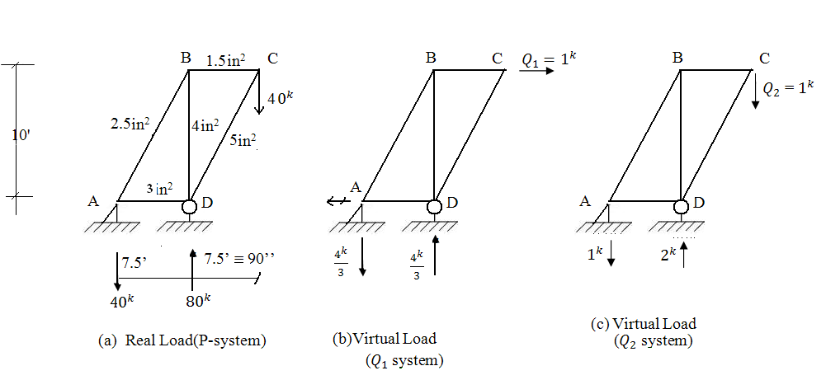

Units used = Kips, Inches
E = Young Modulus (K/${in}^{2})$

For the truss (shown in Fig. a), find the Horizontal & Vertical displacements at Joint C.

Solution for Example 1

- For finding the Horizontal displ. at Joint C (${∆c}_{horiz}$); one applies Virtual Load Q₁ (Fig. b)

- For finding the Vertical displ. at Joint C(${∆c}_{Vert.}$); one applies Virtual Load Q₂ (Fig. c)
- From V.W Formulas (see Eqs. 17; 19 a $→$19d ) , one has ;

W_{s +} $W_{settlement}$ = W_{d} (${Q_{1} = {1 }^{K}→)(∆c}_{horiz}$ ?? )+ $W_{settlement}$ = $\sum_{All members}{F_{Q_{i}}}$ ($\frac{F_{p} L}{AE})_{i}$ .. (20)

(Q₂ = 1^{k} $↓$ ) (${∆c}_{Vert.}$?? ) + $W_{settle}$ = $\sum_{i}{F_{Q_{2i}}}$ ($\frac{F_{p} L}{AE})_{i}$ …………………… (21)

- From Static equilibrium , and applying Methods of Joints in figures (a + b + c ), one gets:

Member | Length$≡$ L | Area$≡$ A | $\frac{L}{A}$ | $$F_{p}$$ | $$F_{Q_{1}}$$ | $$F_{Q_{2}}$$ | $$F_{Q_{1}}\frac{F_{p}L}{A}$$ | $$F_{Q_{2}}\frac{F_{p}L}{A}$$
AB | 150 | 2.5 | 60 | 50 | 5/3 | 5/4 | 5,000 | 3,750
BC | 90 | 1.5 | 60 | 30 | 1 | 3/4 | 1/800 | 1,350
CD | 150 | 5.0 | 30 | -50 | 0 | -5/4 | 0 | 1,875
BD | 120 | 4.0 | 30 | -40 | -4/3 | -1 | 1,600 | 1,200
AD | 90 | 3.0 | 30 | -30 | 0 | -3/4 | 0 | 675
 |  |  |  |  |  |  | $\overline{\sum_{1}{=}8,400}$ | $$\overline{\sum_{2}{=}8,850}$$

- Hence: ${∆c}_{horiz}$. = $\frac{+8400}{E}$ and ${∆c}_{Vert.}$ = $\frac{8850}{E}$

Example 2: 2-D Truss with Applied Load

Find the “relative displacement” of joints C and B.
Area of each bar = 10${ in}^{2}$ = A
Young Modulus = 30,000 $\frac{k}{{in}^{2}}$ = E
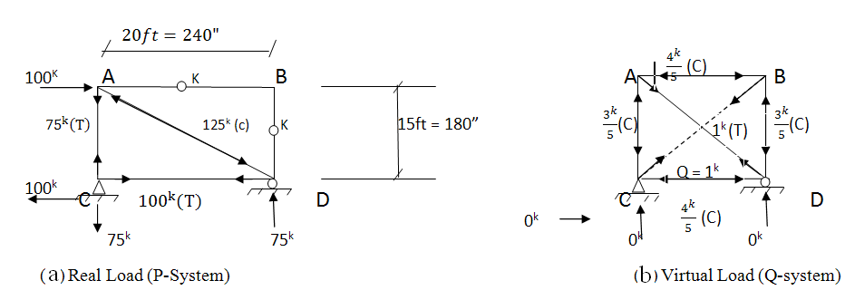

${W_{S} + W}_{settlement}=\left(Q=1^{K}\right)\left(∆_{CB}\right)+ 0=\sum_{i}{F_{Q_{i}}}{\left(\frac{F_{p}L}{AE}\right)}_{i}$
$$= \sum{\{(-\frac{3}{5}}*{75}^{K}*180'')+(1^{K}*-{125}^{K}*300'')+(-\frac{4^{K}}{5}{*100}^{K}*240'')\}*(\frac{1}{AE})$$
$= -\frac{5400}{AE}$

Thus: $∆_{CB}=\frac{-5400}{AE}$ (or $∆_{CB}=\frac{5400}{AE}$ )

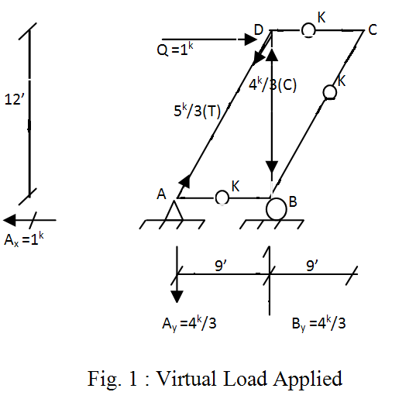
Example 3: Plane Truss
(with Settlements, Fabrication Errors)
The truss shown is subjected to support settlements

At joints A $\{_{2^{''}↑}^{3^{''}→}$ and B $\{_{3^{''} ↓}^{2^{''}→}$

What should be the length of member AD in order to have $(∆_{D})_{Horizontal}$ = 0’’?

Given cross-sectional area of each bar = 20 in² = A
Young Modulus = 30,000 $\frac{K}{in^{2}}$ = E

Solution

- Due to settlements’ effects, horizontal displ. at joint D can be computed as:
W_{s +} $W_{settlement}= W_{d}$ zero
$\left(Q=1^{k} → \right)\left(∆_{D_{Horiz.}}^{1}\right)+\left(+A_{x}=+1^{k}\right)(+3''\text{)+(-}{\text{A}}_{\text{y}}\text{=-}\frac{{\text{4}}^{\text{k}}}{\text{3}}\text{)(2}")+(B_{y}=\frac{4^{k}}{3})(-3")=0$
Thus:$\left(∆_{D_{Horiz.}}^{1}\right)$ $=+(\frac{11}{3})^{in}$ , $or joint D moves$ $to the right.$

- In order to prevent the Horiz. displ. at joint D (due to settlement), length of member AD
has to be adjusted, so that joint D will move back to the left, by the same amount.

${(W}_{s}=1^{K}*\frac{-11in}{3})+W_{settle}=\left(F_{Q_{AD}}=\frac{5^{K}}{3}\right)\left(∆L_{\begin{aligned}Fabrication \\ Error for AD\end{aligned}}??\right)→(∆L_{Fab.Err})_{AD} =-\frac{11"}{5}$
0

Example 4: Plane Truss with Temperature, Pre-strain (or Fabrication Error), Support settlements … effects

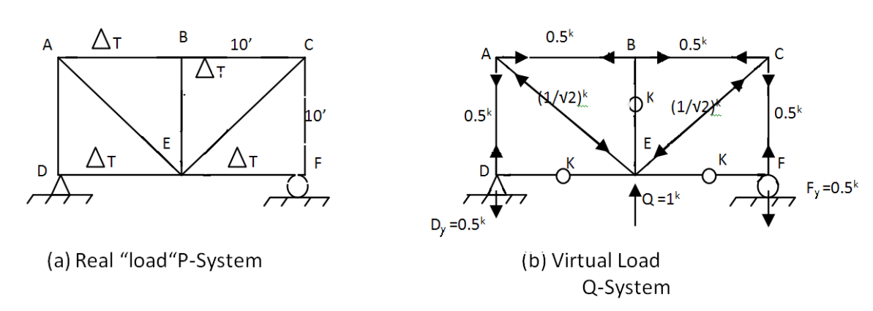
Given: $E=30,000 \frac{k}{{in}^{2}}$
$$α =6.5*{10}^{-6}\frac{in}{in°F}$$

Find: Vertical displ. at joint E.
F_{y} =0.5^{k}
K

F

- Due to temperature of bars AB, BC, DE & EF is raised by 100°F

W_{s +} $W_{settlement}= W_{d}$

$$\left(Q=1^{k} ↑\right)\left(∆_{E_{vert.}}\right)+0=\sum_{i}{F_{Q_{i }}}{(α∆T*L)}_{i }where \left\{\begin{aligned}\begin{aligned}i=bars AB, BC, DE, EF \\ {\left(F_{Q}\right)}_{AB}={0.5}^{k}={\left(F_{Q}\right)}_{BC}\end{aligned} \\ {\left(F_{Q}\right)}_{DE}=0^{k}={\left(F_{Q}\right)}_{EF}\end{aligned}\right\}$$

So: $∆_{E_{vert.}}=+6.5*{10}^{-3}ft (or moves$upward)

- Due to Pre-strain (or Fabrication Error)

Bars AB, BC, DE, EF, AD, BE, CF are 2" too short.
Bars AE, CE are $\sqrt{2}$=1.414” too short

$$W_{S}+W_{settle}=W_{d}$$

$\left(Q=1^{K}↑\right)\left(∆_{E_{vert}}\right)+0=Σ\left(F_{Q_{i}}\right)\left({∆L}_{P_{i}}\right)\text{ where i=AB, …, CF; AE, CE }$
$=\left({0.5}^{k}\right)\left(-2''\text{)+…+}\left({\text{0.5}}^{\text{k}}\right)\text{(-2}\text{''}\right)+\left(\frac{{-1}^{k}}{\sqrt{2}}\right)\left({-\sqrt{2}}^{"}\right)+\left(\frac{{-1}^{k}}{\sqrt{2}}\right)\left({-\sqrt{2}}^{"}\right)$

AB CF AE CE

So: $∆_{E_{vert}}=-2"$ (or moves downward)

- Due to settlements at Joint D$\left\{\begin{aligned}2"← \\ 1" ↓\end{aligned}\right.$ , and at Joint F $\left\{\begin{aligned}3"→ \\ 4" ↓\end{aligned}\right.$

$$W_{S }+ W_{settle} ={ W}_{d}$$

$$\left(Q=1^{K}↑\right)(∆_{E})_{vert}+ \left(D_{y}={-0.5}^{k}\right)\left(-1'')\text{+(Fy=}{\text{-0.5}}^{\text{k}}\text{)(-4}\text{''}\right)= 0$$

So: $∆_{E_{vert}}=-2.5"$ (or moves downward)

- Due to all, combined effects

$(∆_{E})_{vert}= +\left(6.5*{10}^{-3}ft*\frac{12"}{ft}\right)+ \left(-2^{''}\text{)+(-2.5}\text{''}\right)=-4.42"$

Example 5: V.W on Beam
Find the vertical deflection $∆_{c}$ at mid-point of the beam?

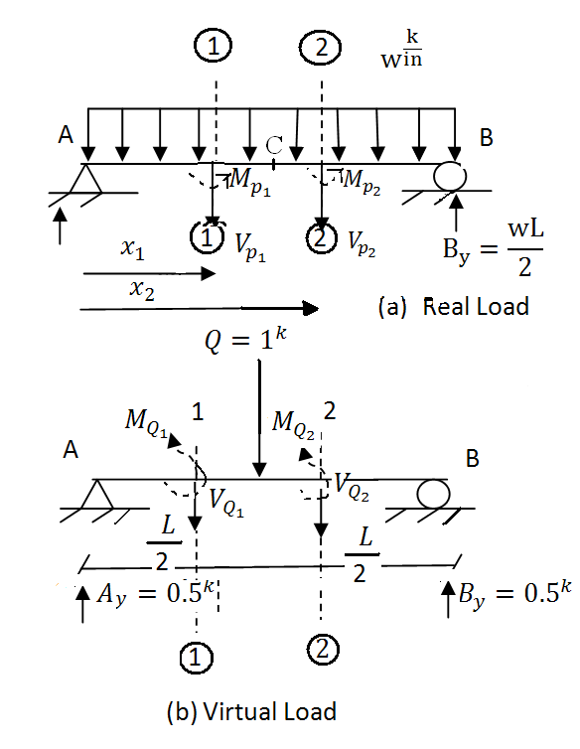
- Use left-side of section (1)-(1) as free Body Diagram (FBD)
$$ΣM_{\left(1\right)-(1)}{}_{=}^{}0=Mp_{1}-\left(Ay=\frac{wL}{2}\right)\left(x_{1}\right)+\left(wx_{1}\right)(\frac{x_{1}}{2})$$
Hence: $Mp_{1}=\frac{wLx_{1}}{2}- \frac{{wx}_{1}^{2}}{2} for 0 ≤ x_{1} ≤\frac{L}{2}$

- Similarly:

$$Mp_{2}=\frac{wLx_{2}}{2}- \frac{{wx}_{2}^{2}}{2}$$
$$for \frac{L}{2} ≤ x_{2} ≤L$$

- Use left-side of section (1)-(1) as FBD:
$$ΣM_{\left(1\right)-\left(1\right)}=0^{}=M_{Q_{1}}-\left(Ay=0.5^{K}\right)\left(x_{1}\right)$$
$So: M_{Q_{1}}=0.5x_{1}$ for $0 ≤ x_{1} ≤\frac{L}{2}$

- Use left-side of section (2)-(2) as FBD:
$$ΣM_{\left(2\right)-\left(2\right)}=0^{}=M_{Q_{2}}-\left(Ay=0.5^{K}\right)\left(x_{2}\right)+\left(1^{k}\right)\left(x_{2}-\frac{L}{2}\right)$$
$So: M_{Q_{2}}=-0.5x_{2}+\frac{L}{2}$ For $\frac{L}{2} ≤ x_{2} ≤L$

Now, applying V.W. formula (see Eq. 19 b)

$$W_{S}+W_{settle}=\int{M_{Q}*\frac{M_{p}}{EI} dx}$$
$$\left(Q=1^{k}↓\right)\left(∆_{c}??\right)+0=\int_{x_{1}=0}^{\frac{L}{2}}{M_{Q_{1}}*\frac{M_{P_{1}}}{EI} dx_{1}}+\int_{x_{2}=\frac{L}{2}}^{L}{M_{Q_{2}}*\frac{M_{P_{2}}}{EI} dx_{2}}$$
Or: $∆_{c}=\int_{x_{1}=0}^{L/2}{(0.5x_{1}})*\frac{\left(\frac{wLx_{1}}{2}- \frac{wx_{1}^{2}}{2}\right)}{EI}dx_{1}+ \int_{x_{2}=\frac{L}{2}}^{L}{\left(-0.5x_{2}+\frac{L}{2}\right)*\frac{\left(\frac{wLx_{2}}{2}- \frac{wx_{2}^{2}}{2}\right)}{EI}}dx_{2}$
Hence: $∆_{c}=\frac{+5wL^{4}}{384EI}$ (or point C will move downward, as we have assumed for direction of Q)

`

Example 6: More on V.W. for Beam
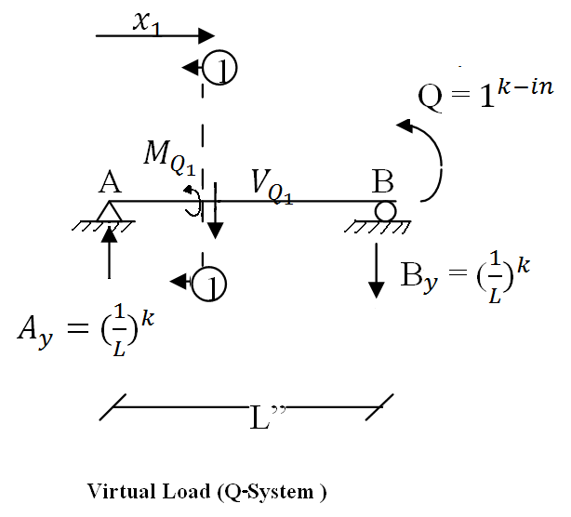
For the same beam (Shown in Example 5), find the rotation ($θ_{B})$ at Joint B

∑$M_{ \left(1\right)-(1 )}$ = $0^{}$ = $M_{Q_{1}}$ – $({Ay= \frac{1}{L})}^{kip}$($x_{1})$

Hence: $M_{Q_{1}}$ = $\frac{x_{1}}{L}$ for 0 ≤ $x_{1}$ ≤ L

Applying V.W. formula (See Eq. 19b):

$W_{S}$ + $W_{settle.}$ = $W_{d}$

(Q = $1^{k-in})\left(θ_{B}\right)$ + 0 = $\int{M_{Q} \frac{M_{p}}{EI}} dx$

Or $\boxed{θ_{B} = \int_{x_{1}=0}^{L}{(\frac{x_{1}}{L}})*\frac{(\frac{wLx_{1}}{2}- \frac{w{x_{1}}^{2}}{2})}{EI} {dx}_{1}}$

Note:
The $M_{p_{1}}$ computed earlier ( see Example 5 ) can also be used for entire beam ( or 0 ≤ $x_{1}$ ≤ L )

Example 7: V.W. on Frame
Given: E = ${30,000}^{{k/in}^{2}}$ ; I = 288${in}^{4}$
Find: vertical deflection at point C? Rotation at point C ?

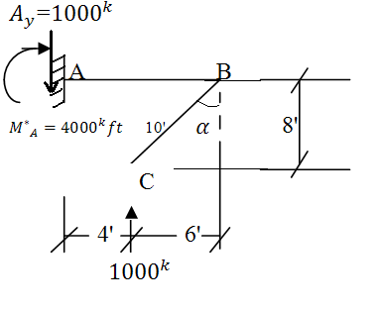

- Real Load, P-System

- Free body Diagrams (for P-system)
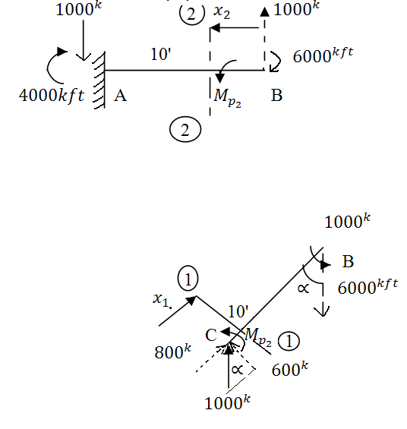
∑$M_{ \left(2\right)–(2)}$= $0^{}$ = $M_{p_{2}}$+ (${1000}^{k}$) ($x_{2}$) - ${600}^{kft}$

So:
$M_{p_{2}}$= ${6000}^{kft}$-1000$x_{2}$
0’ ≤ $x_{2}$ ≤ 10’

∑$M_{ \left(1\right)-( 1) }$= $0^{}$ = $M_{p_{1}}$ - (${600}^{k}$)($x_{1}$)

So:
$M_{p_{1}}$ = 600$x_{1}$
0’ ≤ $x_{1}$ ≤ 10’

Note: To find vertical deflection at point C, we could have also applied a “Virtual” vertical load $Q_{1}$= ${1000}^{k}$ at point C.
Hence, Fig. (b) can also be used for $Q_{1}$-system !

To find vertical deflection ($∆_{c}$) at joint C

$W_{s}$ + $W_{settle}$ = $W_{d}$

($Q_{1}={1000}^{K}$)(${∆^{ft}}_{c}$) + $0^{Kft}$ =$\int{M_{Q}* \frac{M_{p}dx}{EI}}$

Or (1000) ${∆_{c}}^{ft}$ = $\int_{x_{1}=0}^{10}{M_{Q_{1}}}* \frac{M_{p_{1}}}{EI}{dx}_{1} + \int_{x_{2}=0}^{10}{M_{Q_{2}}}* \frac{M_{p_{2}}}{EI}{dx}_{2}$
= $\int_{0}^{10}{{\frac{{(M}_{p_{1})}}{EI}}^{2}}{dx}_{1}+ \int_{0}^{10}{\frac{{(M_{p_{2})}}^{2}}{EI}}{dx}_{2}$

(1000)${∆_{c}}^{ft}$= $\int_{0}^{10}{\frac{({600x_{1})}^{2}}{EI}}{dx}_{1}$+ $\int_{0}^{10}{\frac{{({6000}^{kft}-{1000}_{x_{2}})}^{2}}{EI}}{dx}_{2}$

Thus: ${∆_{c}}^{ft}$= ($\frac{1}{1000})$ {$\int_{0}^{10}{\frac{({600x_{1})}^{2}}{EI}}{dx}_{1}$+ $\int_{0}^{10}{\frac{{(6000-{1000}_{x_{2}})}^{2}}{EI}}{dx}_{2}$ }

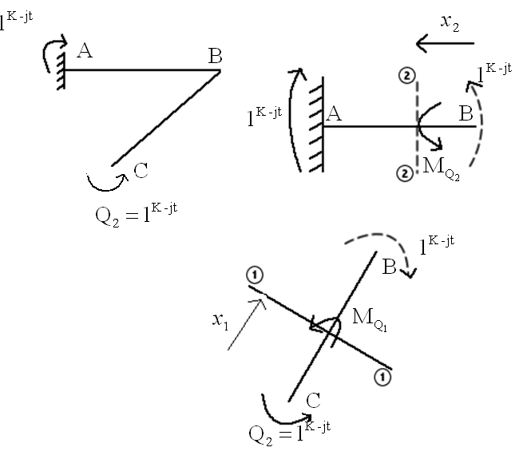
$\sum{M_{\left(2\right)-(2)}= 0^{}=M_{Q_{2}}}+ 1^{K-ft}$

So:
$\boxed{M_{Q_{2}}= -1^{Kft}}$
Valid for 0’ ≤ $x_{2}$ ≤ 10’

$$\sum{M_{\left(1\right)-(1)}= }0^{}=M_{Q_{1}}+ 1^{Kft}$$
So:
$\boxed{M_{Q_{1}}= -1^{Kft}}$
Valid for 0’ ≤ $x_{1}$ ≤ 10’

(C)- Virtual Load ($Q_{2}$-System) and FBD of members AB, BC.

To find ROTATION at joint C

$W_{s}$ + $W_{settle}$ = $W_{d}$

$$\left(Q_{2}=1^{Kft}\right)\left(θ_{C}\right)+ 0^{Kft} = \int{M_{Q}}*\frac{M_{p}dx}{EI}$$

Or: $θ_{C}= \int_{x_{1}=0'}^{10'}{M_{Q_{1}}}*\frac{M_{P_{1}}dx_{1}}{EI}+\int_{x_{2}=0'}^{10'}{M_{Q_{2}}}* \frac{M_{P_{2}}dx_{2}}{EI}$

Or: $\boxed{θ_{C}= \int_{0}^{10}{(-1^{Kft})}*\frac{(600x_{1})}{EI}dx_{1}+\int_{0}^{10}{(-1^{Kft})}* \frac{({6000}^{Kft}-1000x_{2})}{EI}dx_{2}}$

Example 8: V.W. for a Determinate Beam
Find the vertical deflection of joint B.

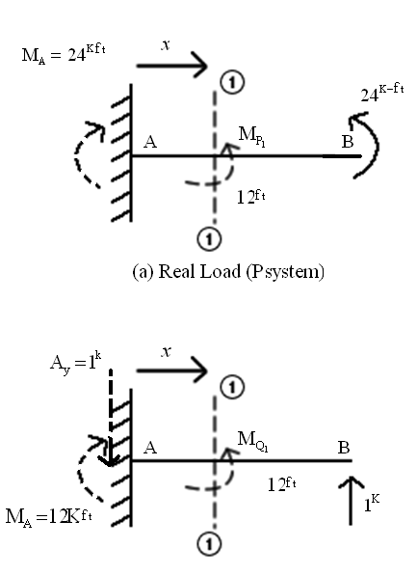
$$W_{s}=W_{d}$$

$\left(1^{k}\right)\left(δ_{B_{V}}\right)+ \left(W_{settle}=0\right)= \int{\frac{M_{Q_{1}}M_{P_{1}}dx}{EI}}$ (8.1)

Use left side of cut section 1)-1) as FBD, then:
$\sum{M_{1}{}_{=}^{}{ 0}}=M_{P_{1}}-{24}^{kft} ⟹M_{P_{1}}={24}^{kft}$ (8.2)

Use left side of the cut section 1)-1) as FBD, then:
$\sum{M_{1}= 0^{}}=M_{Q_{1}}+ \left(1^{k}\right)\left(x\right)- {12}^{kft}$

Hence: $M_{Q_{1}}=12-x (8.3)$

Substitute Eqs. (8.2, 8.3) into Eq. (8.1), one gets

$δ_{B_{V}}= \int{\frac{\left(12-x\right)\left(24\right)(dx)}{EI}}$= …

(b)- Virtual Load (Q-System)

Example 9: V.W. for Determinate Beam
Find the vertical deflection at joint B? (Refer to example 8)

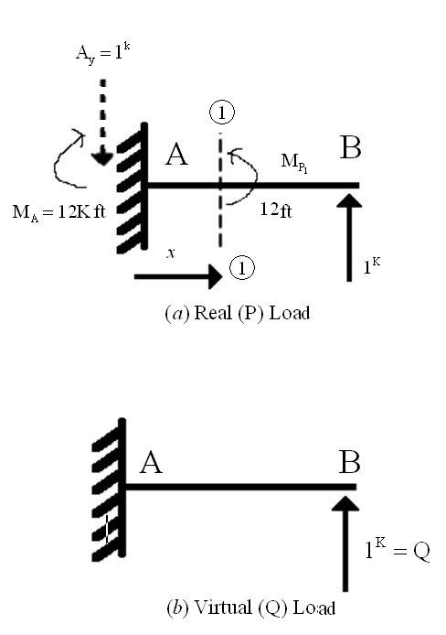

$$W_{s}=W_{d}$$

$$\left(Q=1^{k}↑\right)\left(δ_{B_{V}}\right)+\left(W_{settle}=0\right)\int{\frac{(_{{M_{q}}_{1}(M_{P_{1}}={M_{q}}_{1})}}{EI}}dx$$

$δ_{B_{V}}= \int{\frac{{\left({M_{q}}_{1}\right)}^{2}dx}{EI}}=\int_{0}^{12 }{\frac{{\left(12-x\right)}^{2}}{EI}}dx=…$

Example 10: V.W. for simply support, Determinate Beam
Find the ROTATION at joint A.

Use left side of cut section 1)-1) as FBD;

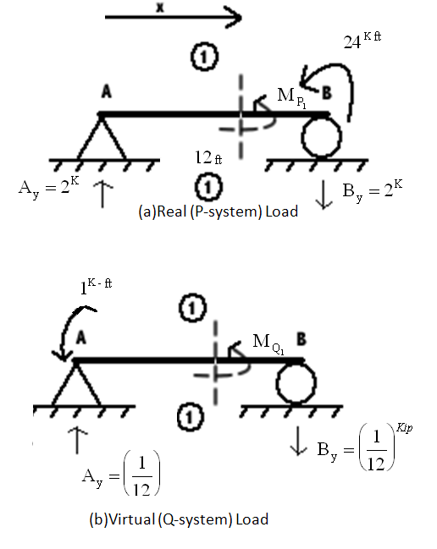
$\sum{M_{(1)}=0^{}}=M_{P_{1}}-\left(2^{K}\right)\left(x\right)⟹M_{P_{1}}=2x..(10.1)$

$\sum{M_{(1)}=0^{}}= M_{Q_{1}}+1^{kft}-(\frac{1}{12})(x)$

Hence: $M_{Q_{1}}= \frac{x}{12}-1$ ……….…(10.2)

Use V.W:

$$W_{s}+ W_{settle}=W_{d}$$

(Q=$1^{Kft}⤣)\left(θ_{A}\right)+ 0= \int{\frac{M_{Q_{1}}M_{P_{1}}}{EI}}dx$

$θ_{A}=\int_{0}^{12}{(\frac{x}{12}}-1)\left(2x\right)\frac{dx}{EI}=…$

Example 11: V.W. for Simply Support, determine beam.
Find the rotation at Joint A.

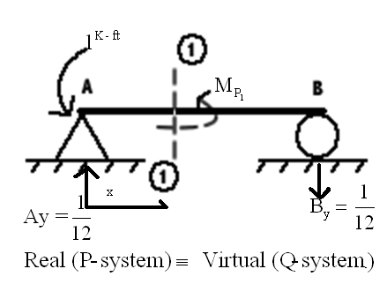
Use left side of cut section (1)-(1) as FBD;

$$\sum{M_{1}=0^{}}= M_{P_{1}}+1^{kft}-\left(\frac{1}{12}\right)\left(x\right)$$

Hence: $M_{P_{1}}=$ $\frac{x}{12}-1≡ M_{Q_{1}}$

Apply VW:

$W_{s}+$ ${(W}_{settle}=0)$ = $W_{d}$

(Q=$1^{kft}⤣)\left(θ_{A}\right)+ 0= \int{M_{Q_{1}}}M_{P_{1}}\frac{dx}{EI}$

$$θ_{A}= \int_{0}^{12}{(}\frac{x}{12}-1)^{2}\frac{dx}{EI}=…$$

Example 12
Find the vertical displacement at joint B?
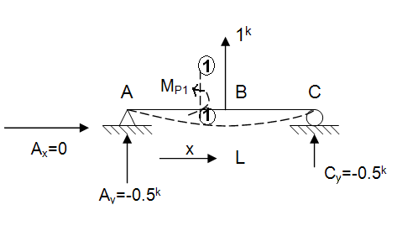
Use left-side of cut section (1)-(1) as FBD.

$\sum{M_{cut( 1)}}=0= M_{P_{1}}-\left(A_{y}\right)(x)$

So: $M_{P_{1}}= A_{y}x=\left(-0.5\right)x ≡ M_{Q_{1}}$

Real (P-System) $≡$ Virtual (Q- System)

Apply V.W.

$W_{s}+$ $W_{settle}$ = $W_{d}$

(Q=$1^{K}↑)\left(δ_{BV}\right)+ 0= \int{M_{Q_{1}}}M_{P_{1}}\frac{dx}{EI}$

$$δ_{BV}= \int_{0}^{L}{(-0.5 x)^{2}}\frac{dx}{EI}= …$$

